**R Code for Examples in the book**

***“Statistics: The Art and Science of Learning from Data”***

**by Agresti, Franklin and Klingenberg, 5th edition**

**Chapter 2**

**Example 3: Shark Attacks in the U.S. – Bar and Pie Charts**

## Create dataset:

state <- c('Florida', 'Hawaii', 'South \n Carolina',   
 'California', 'North \n Carolina', 'Texas', 'Other')  
frequency <- c(203, 51, 34, 33, 23, 16, 27)

## Create basic piechart:

pie(frequency, labels = state, col = rainbow(7),   
 main = 'Pie Chart of Shark Attacks')

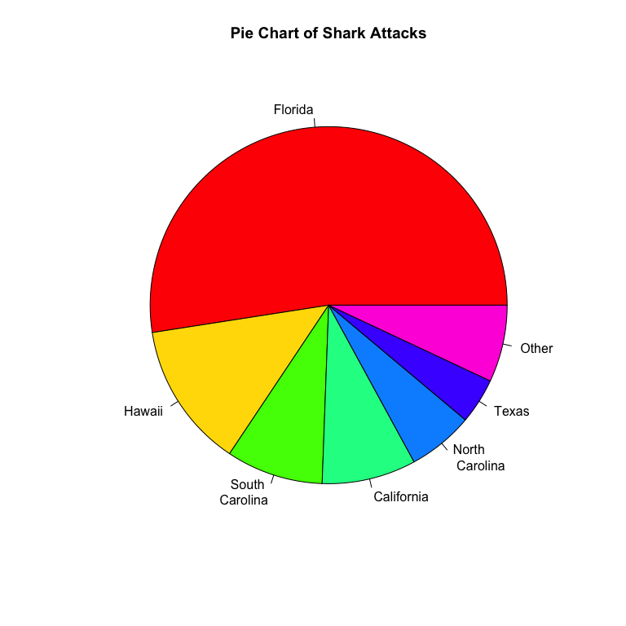

## Create basic bar graph showing counts:

barplot(frequency, names.arg = state, cex.names=0.8, col=rainbow(7),   
 main='Bar Chart of Shark Attacks',  
 xlab='State', ylab='Frequency')

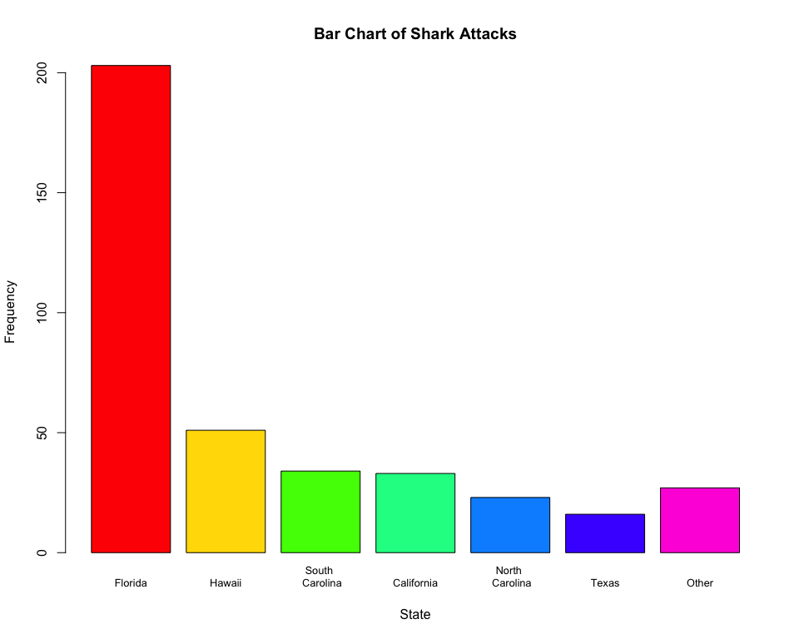

## 

## Create basic bar graph showing percentages:

percent <- 100 * (frequency / sum(frequency))  
barplot(percent, names.arg = state, cex.names = 0.8, col = rainbow(7),   
 main='Bar Chart of Shark Attacks',  
 xlab='State', ylab='Percent (%)')

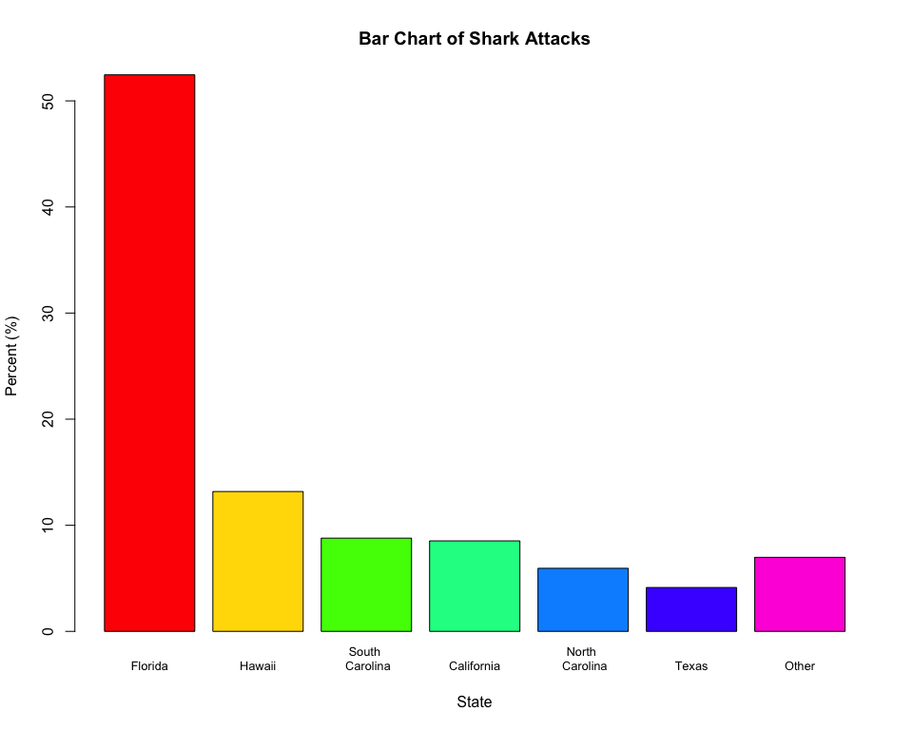

## 

## A better-looking bar graph can be obtained with the ggplot2 library. To install the ggplot2 library, use install.packages('ggplot2')

library(ggplot2)  
plotdata = data.frame(state, frequency)  
ggplot(data = plotdata,   
 aes(x = state,   
 y = frequency,  
 fill = state)) +   
 geom_col(show.legend = FALSE) +  
 labs(title = 'Bar Chart of Shark Attacks',  
 x = 'State', y = 'Frequency') +  
 theme_classic()

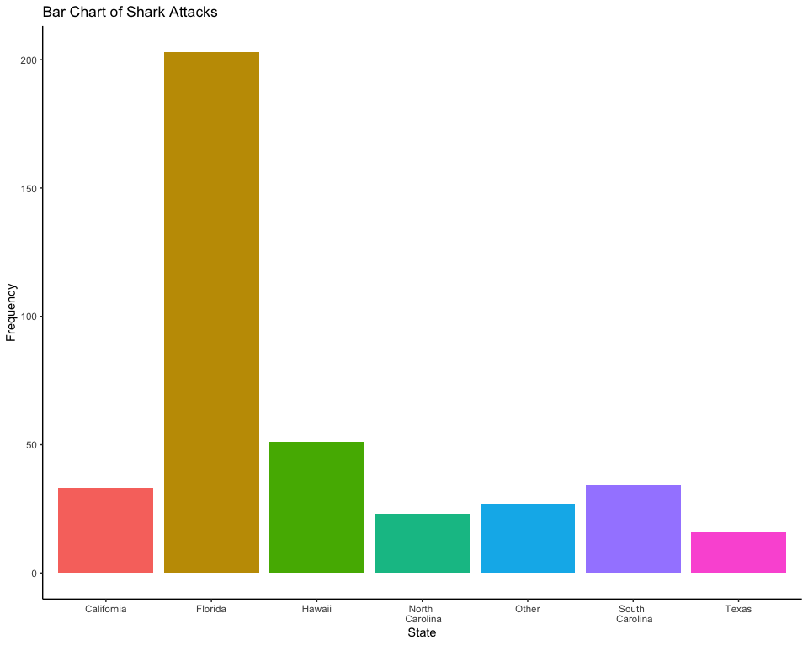

## 

## Or use the geom_bar function with stat = identity

ggplot(data = plotdata,   
 aes(x = state,   
 y = frequency,  
 fill = state)) +   
 geom_bar(stat = 'identity',  
 show.legend = FALSE) +   
 labs(title = 'Bar Chart of Shark Attacks',  
 x = 'State', y = 'Frequency') +  
 theme_classic()



## To manually sort in decreasing order but with Other as the last category you can use the mutate() function from the dplyr package along with the fct_relvel() function from the forcats package. To install both packages, use install.packages('dplyr') and install.packages('forcats').

library(dplyr)  
library(forcats)  
plotdata1 = plotdata %>%   
 mutate(state =   
 fct_relevel(state, c('Florida', 'Hawaii', 'South \n Carolina',   
 'California', 'North \n Carolina',   
 'Texas', 'Other')))  
ggplot(data = plotdata1,   
 aes(x = state,   
 y = frequency,  
 fill = state)) +   
 geom_col(show.legend = FALSE) +   
 labs(title = 'Bar Chart of Shark Attacks',  
 x = 'State', y = 'Frequency') +  
 theme_classic()

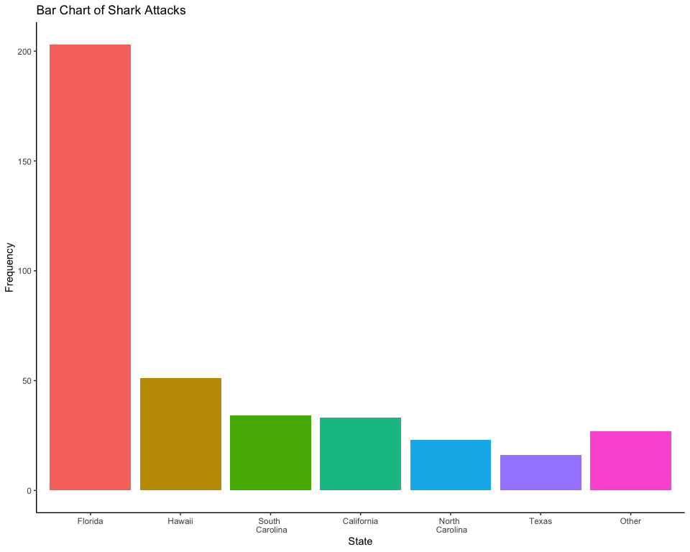

## Note that the ggplot2, dplyr, and forcats packages are all conveniently included within the tidyverse package. So you can instead use install.packages('tidyverse') and then use the library(tidyverse) function.